DBMS

Read and write in transaction:
Read(X): Read operation is used to read the value of X from the database and stores it in a buffer in main memory.
Write(X): Write operation is used to write the value back to the database from the buffer.
1. R(X);
2. X = X - 500;
3. W(X);
Let's assume the value of X before starting of the transaction is 4000.
The first operation reads X's value from database and stores it in a buffer.
The second operation will decrease the value of X by 500. So buffer will contain 3500.
The third operation will write the buffer's value to the database. So X's final value will be 3500

Commit:
Changes of that particular transaction is saved permanently and cannot be able to rollback.
Abort/rollback:
reverting the database back to its state before the transaction begin.

Dirty read:
read of uncommitted data by a particular transaction.
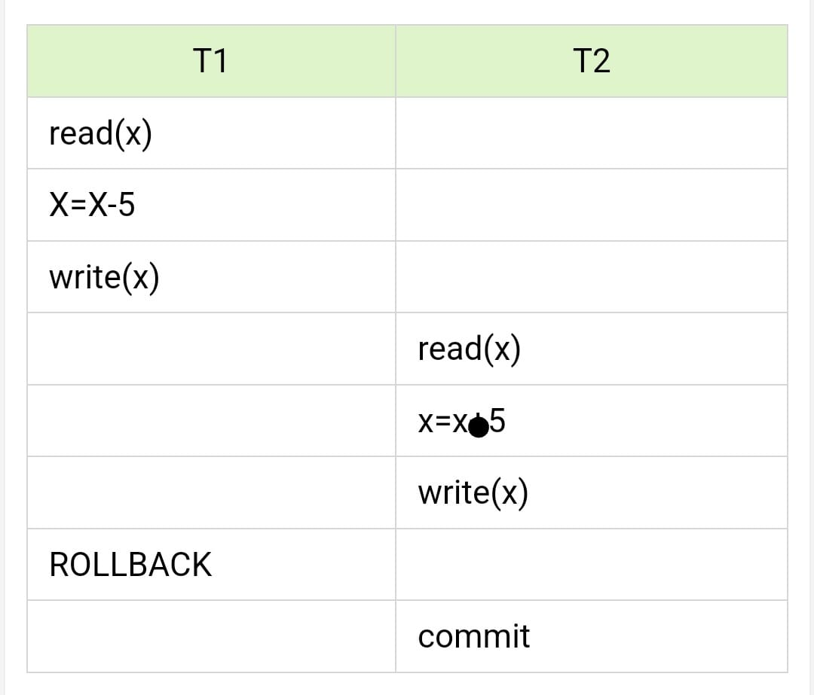
Let initially x value be 100.
During 3rd line x value in the database is modified as 95
During 4th line x is read as 95.
During 7th line because of some failure changes are rollbacked i.e x value is again 100.
As there is no rollback for the T2 wrong value is read in the line 4.

Non repeatable read:
occurs when a transaction reads the same row twice and gets a different value each time.
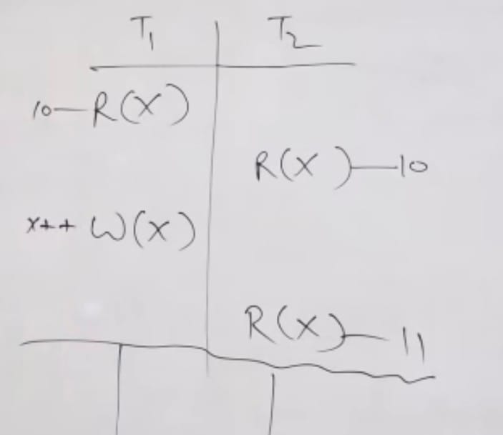
Phantom read:
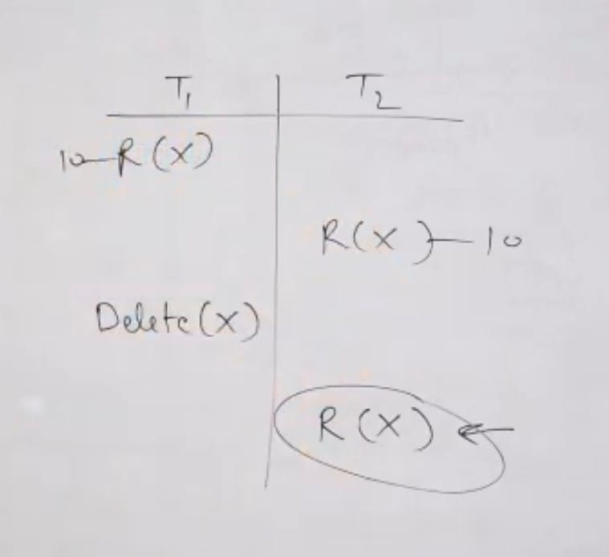
occur when a transaction retrieves a set of records based on conditions but other transactions insert or delete records that meet those conditions.

ACID properties:
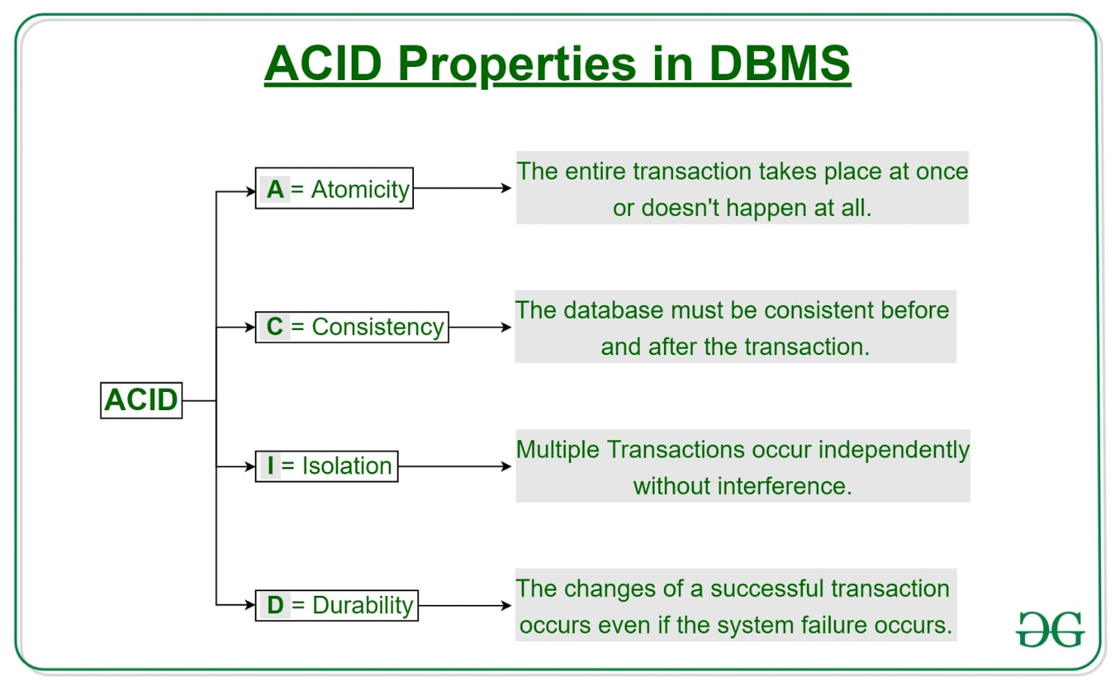
1.Atomicity: either all or none.
i.e either transaction should be done completely or if there is any failure in between transaction it should be restarted but not resumed.
For example in ATM online transaction after entering every detail if there is a failure while entering pin, then home page is displayed but not pincode page.
Ex: transfer of 100rs from X to Y:
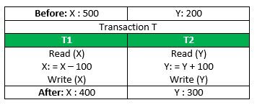
If the transaction fails after completion of T1 but before completion of T2.( say, after write(X) but before write(Y)), then the amount has been deducted from X but not added to Y
2.Consistency:
This means that integrity constraints must be maintained so that the database is consistent before and after the transaction
Ex: total amount before and after transaction should be maintained.
Total before T occurs = 500 + 200 = 700.
Total after T occurs = 400 + 300 = 700.

3.Isolation:
Multiple transactions should occur independently without any interference.
Levels of isolation:
a.Read committed:(1st level)
When a transaction reads a data item, it sees the most recently committed version of that item.
Ex1:initially x=100
T1: read(x)
T1: x++
T1: write(x)
T2: read(x)
T1: commit
T2: commit
Output for 4th line = 100
Here dirty read problem is rectified but non repeatable read problem is still there
Ex2: initially x=100
T1: read(x)
T1: x++
T1: write(x)
T2: read(x)
T1: commit
T2: read(x)
T2: commit
Here 4th line gives 100 but 6th line gives 101. So non repeatable read problem is there.
b.repeatable read:(2nd level)
once a transaction reads a data item, it will continue to read the same value for that item throughout the transaction, regardless of any updates committed by other transactions or itself in between.
This is because it will take snapshot of the database at the beginning of the transaction(but not sequence) and it reads the values inside the snapshot through the entire transaction.
Here the snapshot contains most recently committed values of the variables.
Here both dirty read and non repeatable read are rectified.
Ex1: Initially x=100
T1: read(x)
T1: x++
T1: read(x)
T1: write(x)
T1: commit
Ans: 1st line = 100, 3rd line = 100
Final value of x in the database= 101
Ex2:Initially x=100
T1: read(x)
T1: x++
T1: write(x)
T1: commit
T2: read(x)
T2: commit
Ans: T2 reads it as 101. Because snapshot obviously contains most recently committed ones.
Ex3: Initially x=100
T1: read(x)
T1: x++
T1: write(x)
T2: read(x)
T1: commit
T2: commit
Ans: T2 reads it as 100.
Ex4:Initially x=100
T1: read(x)
T1: x++
T1: write(x)
T2: read(x)
T1: x++
T1: read(x)
T1: write(x)
T1: commit
T2: read(x)
T2: write(x)
T2: commit
Ans: 1st line = 100, 4th line = 100, 6th line = 100, 9th line = 100
Final value of x in the database is 100 as finally write(x) is done by T2 and value of x in the local buffer of T2 is 100
c.serializable:
Results produced by the given sequence of non serial transaction should be same as a sequence in which transactions occurs in some serial order.
It's the highest level of isolation which also rectifies phantom reads

4.Durability:
Changes done due to a successful transaction are permanent even if a system failure occurs

ER model:
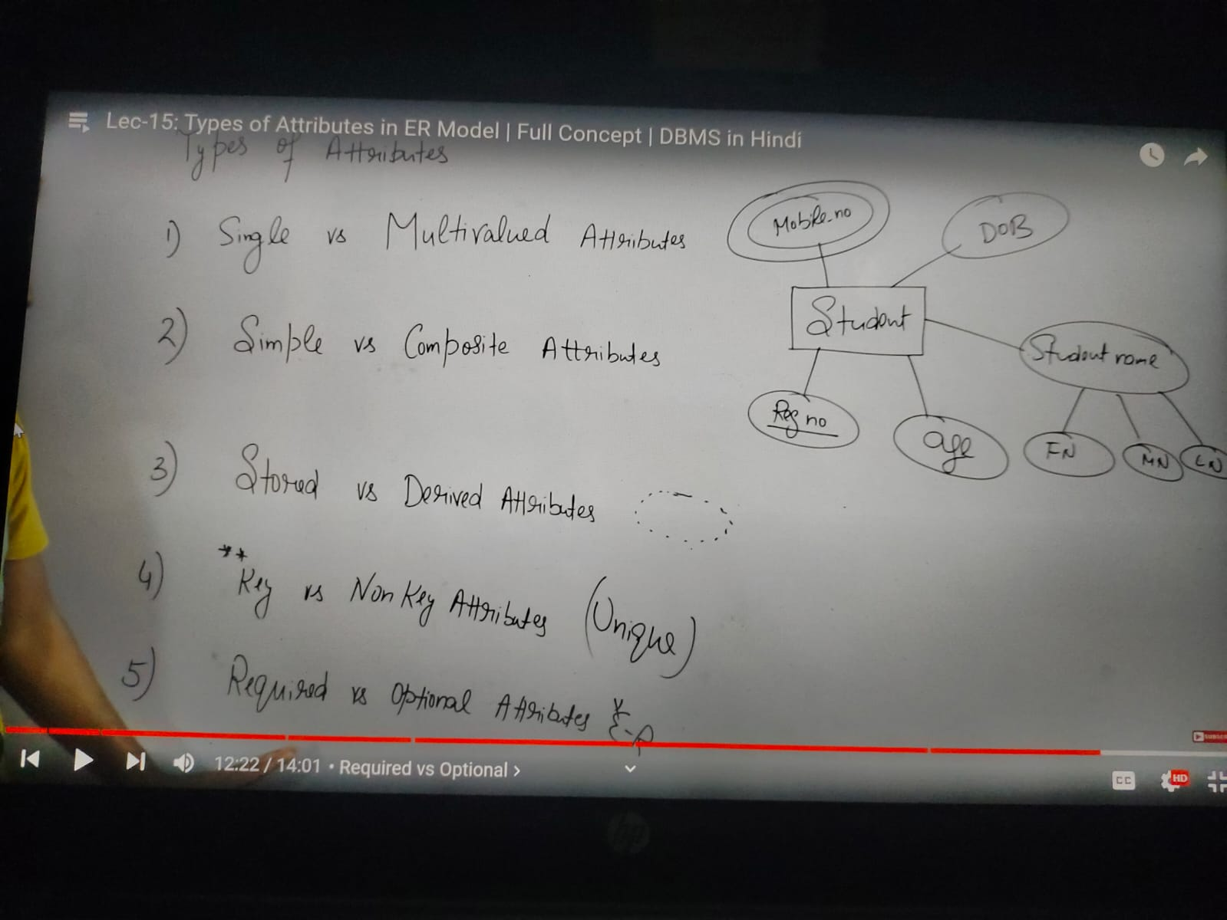
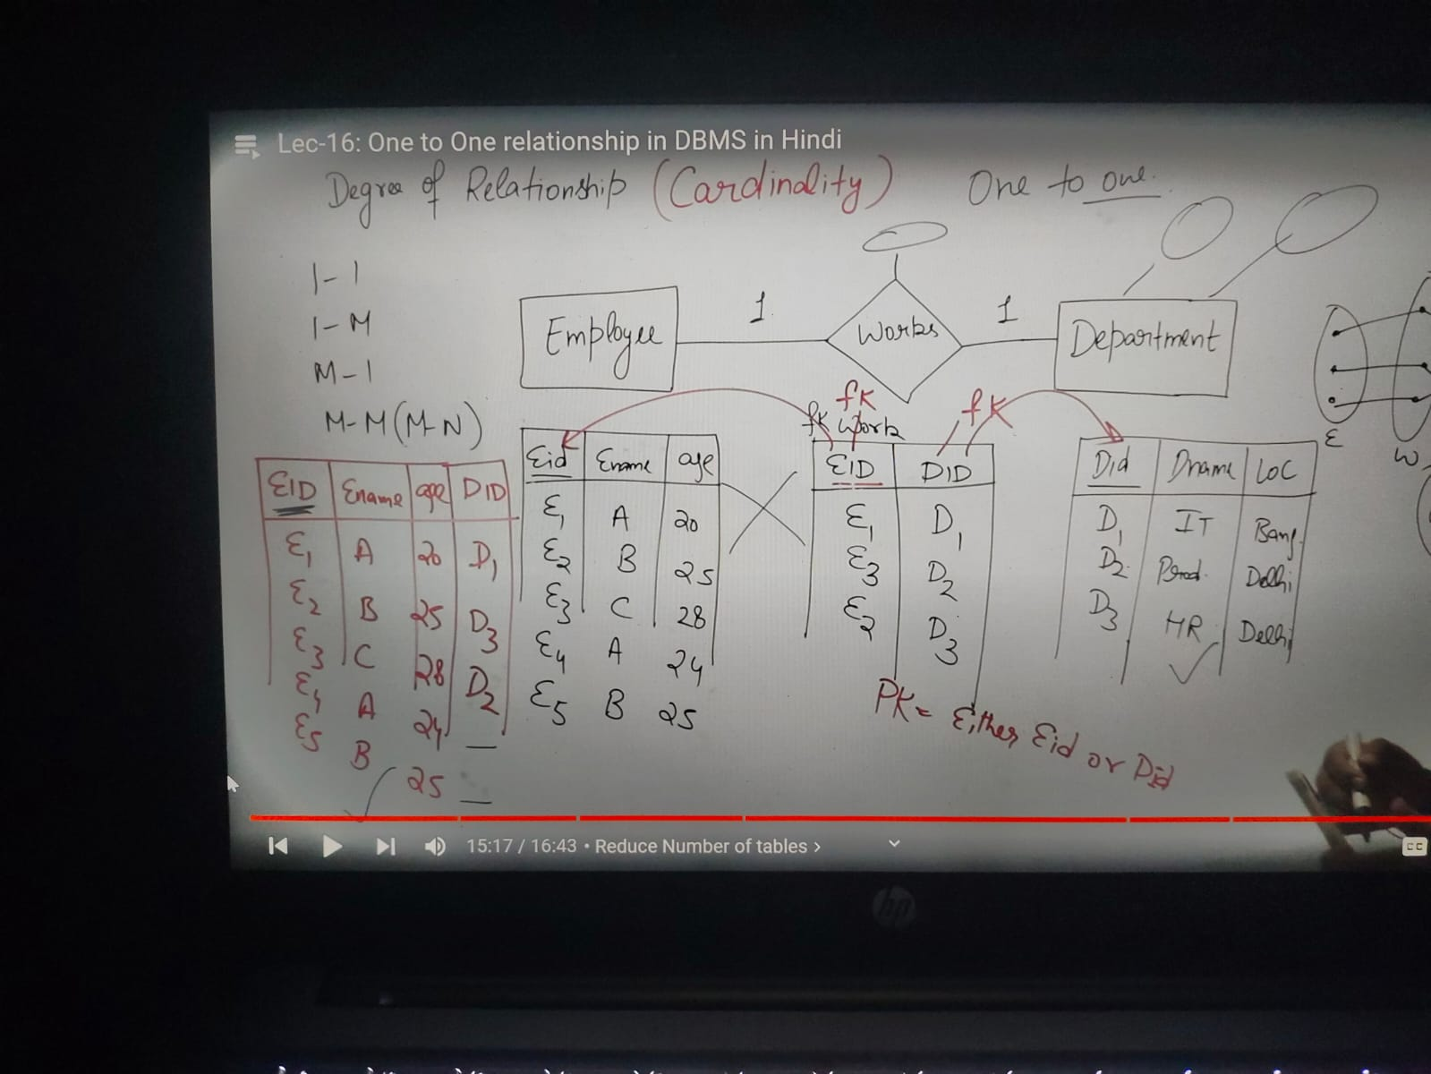

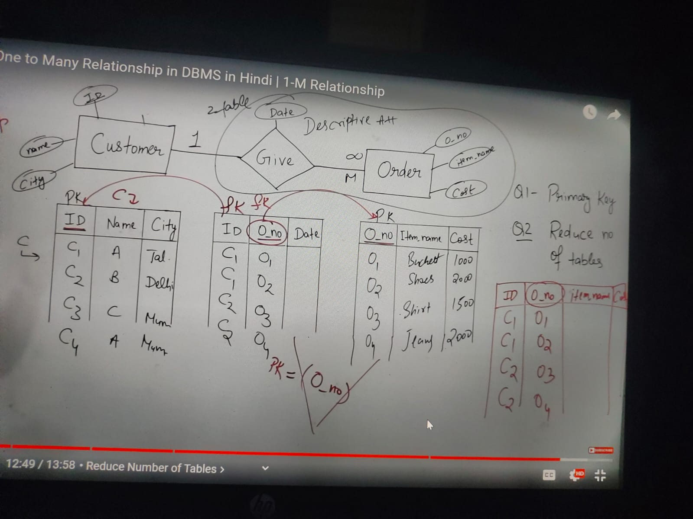

Learn how to get candidate keys from the functional dependencies
Checking for the lossless decomposition and dependency preserving decomposition

Superkey : set of attributes which uniquely identifies a tuple
Candidate key : superkey in which no subset is a super key
Primary : Any candidate key in which no value is NULL

Structured database(in form of tables)
Unstructured database(used for simple web pages with some images)
Operations on structured database like insert, update, delete - RDBMS
Ex. MySQL, SQL, Oracle
Operations on unstructured database - DBMS
Ex. XML, forxpro

Constraint and trigger:
Constraint is applied to a single table and it only checks whether the entered new row is valid or not.
Trigger can keep the constrain between columns of 2 different tables and also update or delete already entered rows

DBMS should follow the below:
1.concurrent use of site by multiple users should be managed in a consistent manner.
2.still able to work irrespective of system failures.
Ex. If particular part of data was destroyed, it should already be copied into another geographic location.
Consider particular process is modifying some data, if it failed after partial modification then this partial modification should not be reflected on the database.

2 tier architecture:
maintainence easy but no security because of direct connection between clients and server
3 tier architecture:
Application server or business layer is in between clients and server which processes the queries send by the clients and convert them into machine language and then sent it to database. Transfer of output from database to application server and then application server to client. Because of this intermediate layer, there is a decrease of load on database.

3 schema architecture::
View level: data that is visible to client(frontend)
Logic level: tables and relationship among them.
Physicsal level: every minute detail regarding database is present here.

Data independencies :
1. Logical data independence :
When a particular client added a new column for a table this change will not be reflected on the actual logical level data. Because views(virtual table) take care of maintaining that consistency.
2. Physical data independence:
When the meta data of a particular data is changed it will not be reflected on logical level data

Foreign key: it can not exist independently. Each value in the foreign key refers to exactly one value of primary key
1.On delete cascade
2.On update cascade
3.entered values in foreign key should be already present in primary key.

Read about integrity constraints:

Primary key table :
Insert (no violation)
Delete (violation)
Update (violation)

Foreign key table:
Insert(violation)
Delete (no violation)
Update (violation)

